After Installing: Configuring With SQLite
DerbyNet uses a database to store all the data for each event. In most cases, SQLite is the preferred database engine for DerbyNet. (See http://www.sqlite.org/whentouse.html for some additional discussion.)
This document describes configuring DerbyNet site with a SQLite database.

Set Up Database

Create Database File
If you've just installed DerbyNet, you can visit http://localhost, which should redirect to http://localhost/derbynet/database-setup.php, and see that you don't yet have a configuration file:
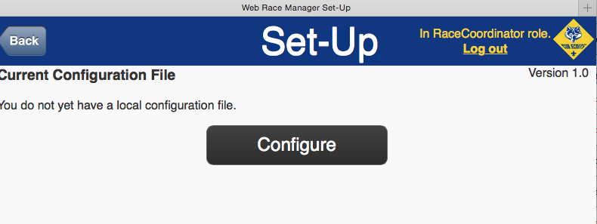
If you've already done this once, and now you want to switch to a different configuration, just visit http://localhost/derbynet/database-setup.php explicitly. Alternatively, if you delete the configuration files in the local directory, DerbyNet will once again be in a just-installed state.
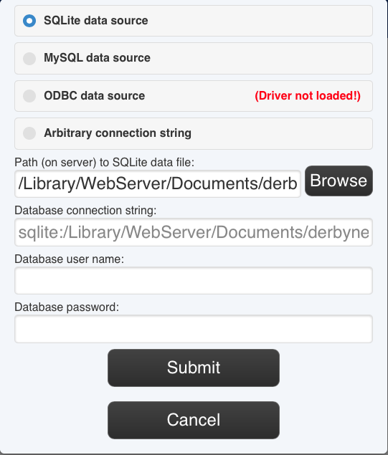
Clicking the Configure button brings up the database configuration dialog shown here. Choose “SQLite data source,” and enter the full path name (on the server) of your database file. For a SQLite database, you don't need a user name or password. Click the “Browse” button to choose a file location interactively.
The database file can be named anything you like, and can be stored in any folder for which the _www user has write access. (If web site security is not a concern, note that _www has write access to the folder at /Library/WebServer/Documents/derbynet/local.)
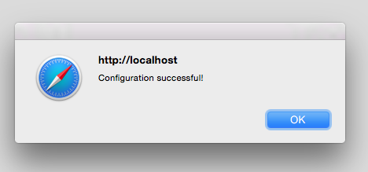
Click the “Submit” button, and you should see a confirmation that the database is correctly configured.

Initialize the Database Schema
Click "Initialize Schema". Despite the warnings, have no fears about initializing a database that’s empty to begin with!

Optional: Adjust User Roles
If desired, edit the file config-roles.inc that's now present in the local subdirectory (i.e., /Library/WebServer/Documents/derbynet/local/config-roles.inc) to change the roles, passwords, or permissions:
open -a TextEdit /Library/WebServer/Documents/derbynet/local/config-roles.inc

Optional: Remove Write Permissions
It's a good practice to remove write permissions from your 'local' subdirectory after initialization:
sudo chmod -R 755 /Library/WebServer/Documents/derbynet/local

